**N4D3E16 16-channel RS485 IO input and output controller Manual**

* [2CH RS485 Relay Serial HyperTerminal Enter](http://v.youku.com/v_show/id_XMTM0ODY4NzkxMg==.html):

**http://v.youku.com/v_show/id_XMTM0ODY4NzkxMg==.html**

* [2CH RS485 Relay Modbus Poll Enter](http://v.youku.com/v_show/id_XMTM0ODY4OTg5Mg==.html)(Usage 2-channel and 8-channel is the same):

**http://v.youku.com/v_show/id_XMTM0ODY4OTg5Mg==.html**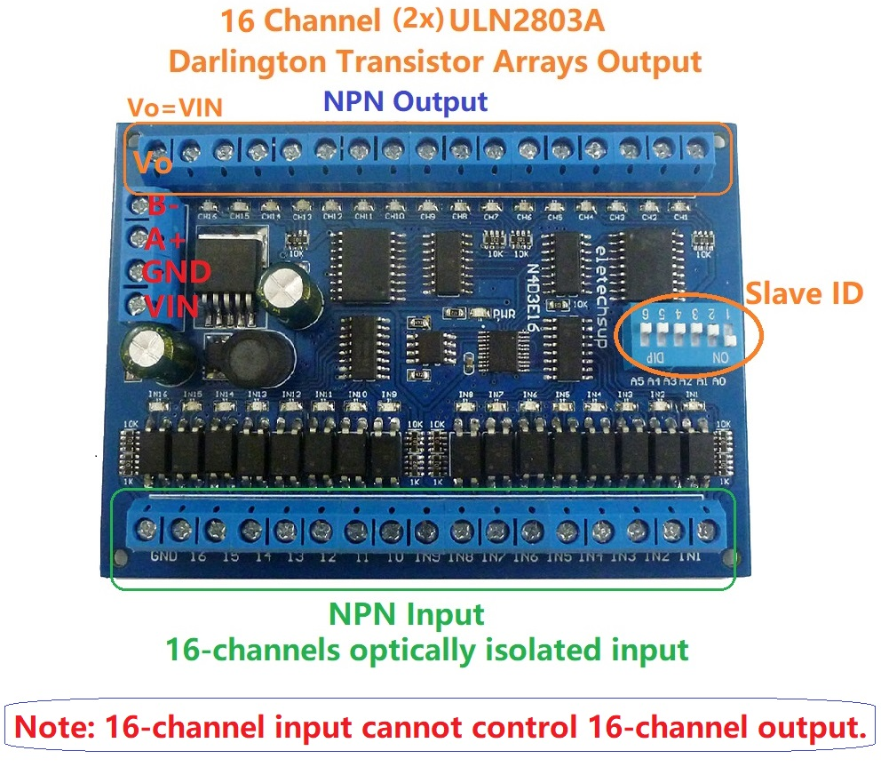

**1. Features:**

1: Working voltage: DC 6.5-30V (9V 12V 24V)

2: Working current: 8-50MA

3: 16 channels photoelectric isolation Input ports (NPN low level active )

4: 16 channels Darlington output (ULN2803 NPN output)

5: "open" "close" "Momentary" "Self-locking" "Interlock" "Delay" 6 Commands

6: 16 inputs can remotely control 16 outputs of another board via RS485 bus (relevant registers must be set)

7: MODBUS RTU command, Support 03 06 function code(Some registers support 16 function codes)

8: Under the "Delay" command ,the maximum delay is 255 seconds;

9 MODBUS commands can be made serial HyperTerminal (serial assistant) OR "Modbus Poll" Enter;

10 Under the MODBUS command mode, it can support up to 64 devices in parallel

11 The default baud rate is 9600BPS. The baud rate can be selected through jumpers: 2400 4800 9600 19200BPS

12 Size: 100 * 72 * 20mm(Only PCB Board);120 * 88* 42mm(with Din Rail Box)

13 Weight: 64g(Only PCB Board);143g(with Din Rail Box)

14 Maximum load: the maximum load current of each channel is 300MA

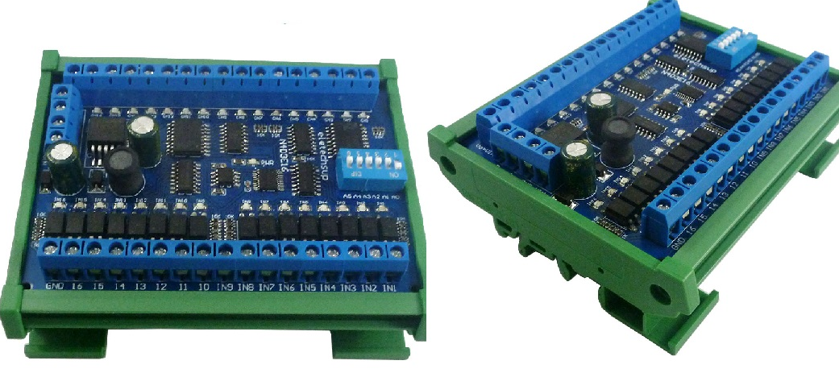

DIN rail Box parameters:

Product model: UM72

Color: green

Width: suitable for PCB board width UM72(72mm)

Insulation grade: flame-retardant VO grade

Backplane length: suitable for 136 mm PCB boards

Net weight: 99g

Installation: DIN35 and C45 rail

**2. Glossary:**

Vo: equal to the working voltage DC 6.5-30V

CH1/2/3…16: 16 output ports, low-level output

"Open": the output port outputs low level

"Close": The output port outputs high impedance (floating)

Momentary : Enter the Momentary command, the Rreceiver Relay is Open, delay of 0.5 seconds after, Relay is Close;

Toggle : Enter the Toggle command, the Rreceiver Relay is Open, Enter the Toggle command again, Relay is Close;

Latched : Enter the Channel 1 Latched command, the receiver Channel 1 is Open, the Channel 2 is Close.

Enter the Channel 2 Latched command the receiver Channel 2 is Open, the Channel 1 is Close.

Enter the Channel 3 Latched command the receiver Channel 1 is Close, the Channel 2 is Close.

Delay : Enter the Delay command, the Rreceiver Relay is Open, delay of 0-9999 seconds(MODBUS command is 0-255 seconds )after, Relay is Close;

During the delay, Eter the Close command, immediately close the relay

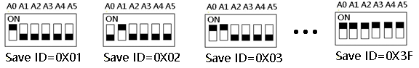

Slave ID: A0-A5 is the slave ID, you can choose 64 different slave ID.

Under the MODBUS command mode,the slave ID must be correct

command Description, Please refer to " N4D3E16 16-channel RS485 IO input and output controller commamd"

3 .Output description

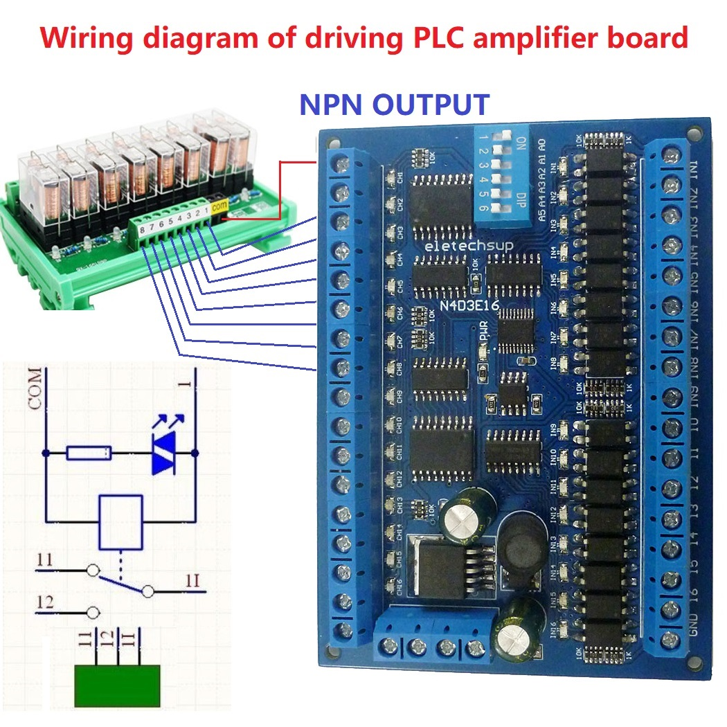

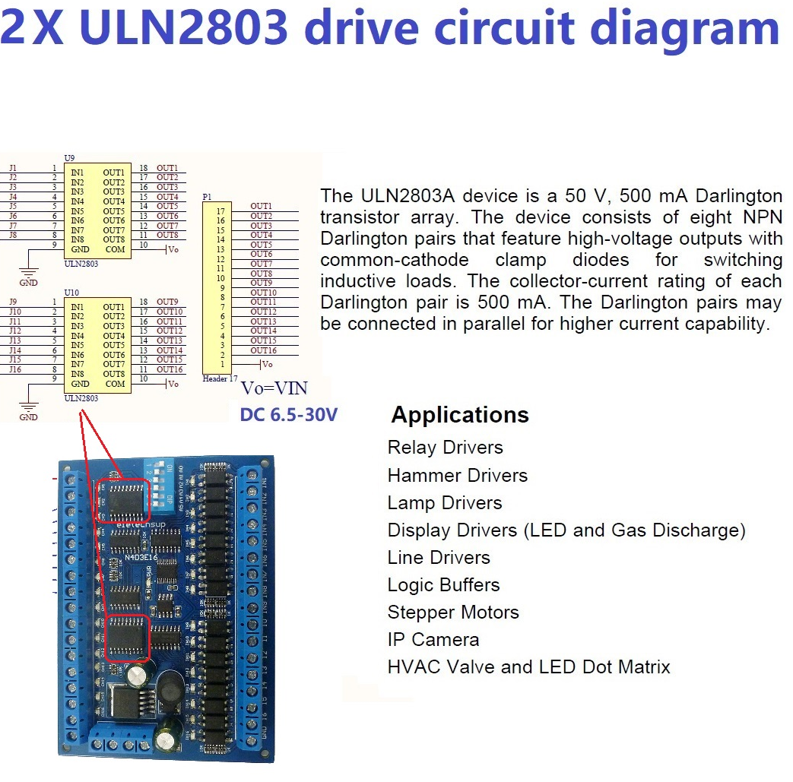

4. Input and output wiring diagram:

Application 1: Control 16-channel switch output through RS485 bus

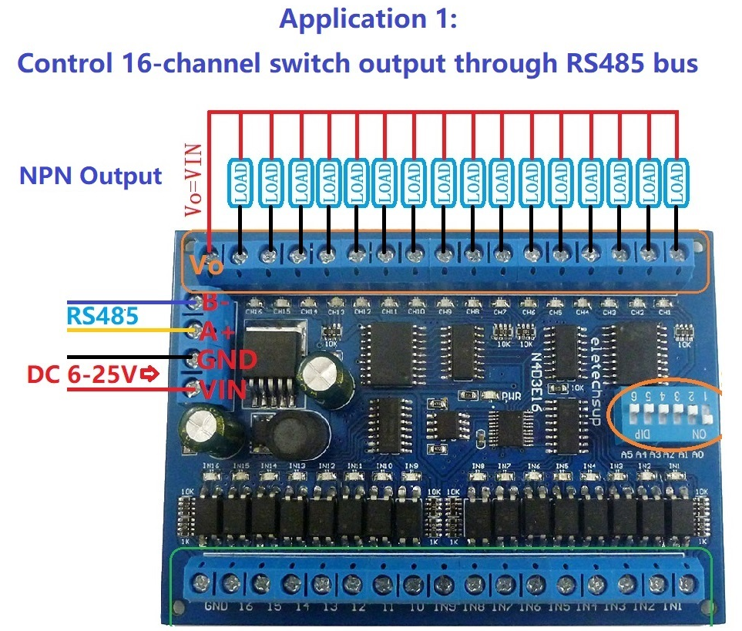

Application 2: Read 16-channel switch input via RS485 bus

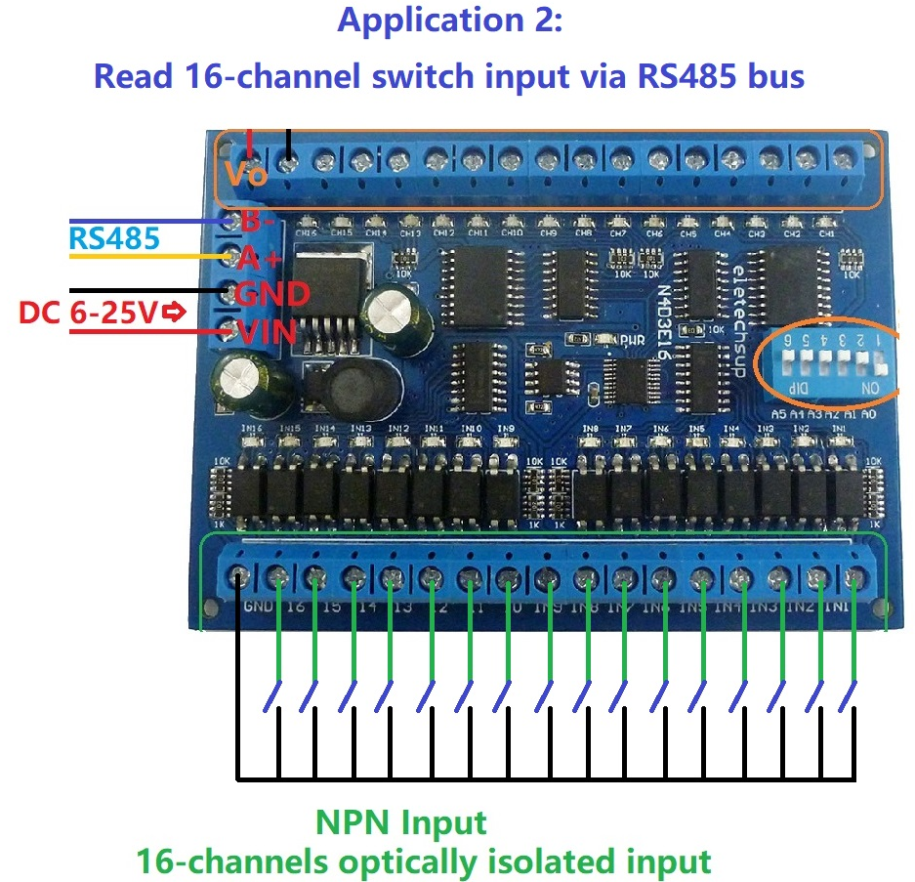

Application 3: 16-channel input remote control 16-channel output

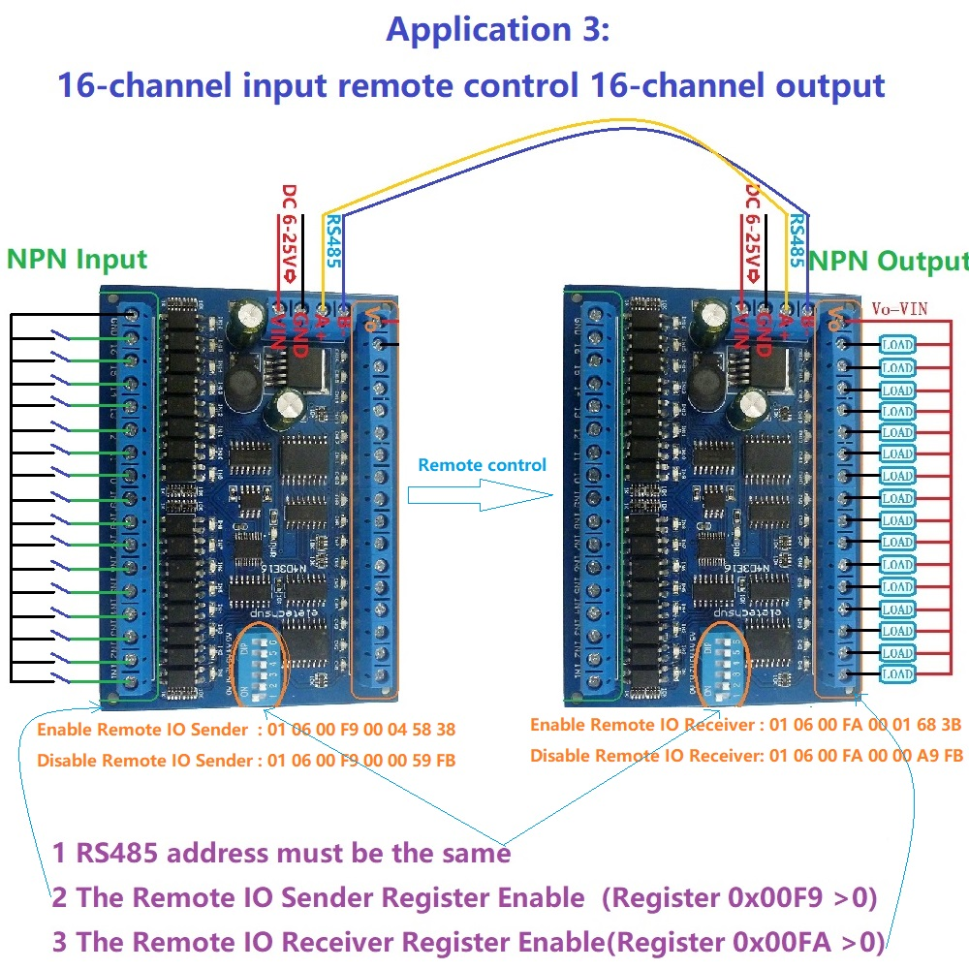

5 Typical applications:

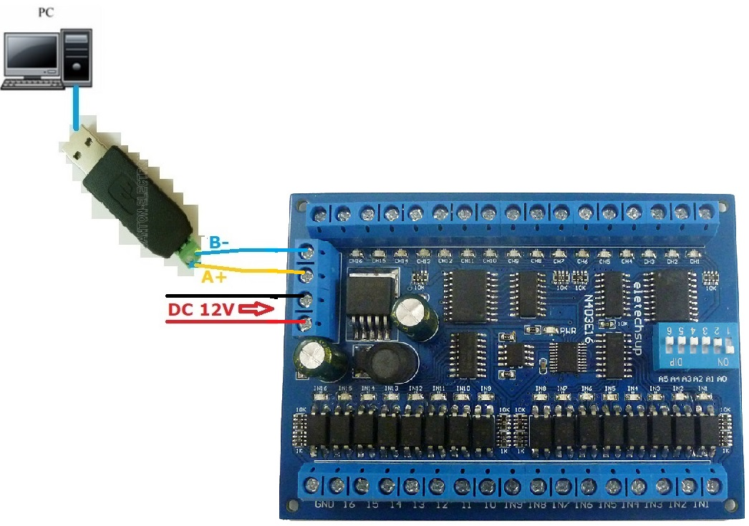

1 The dial switch (slave address) is invalid and can only control one module at a time.

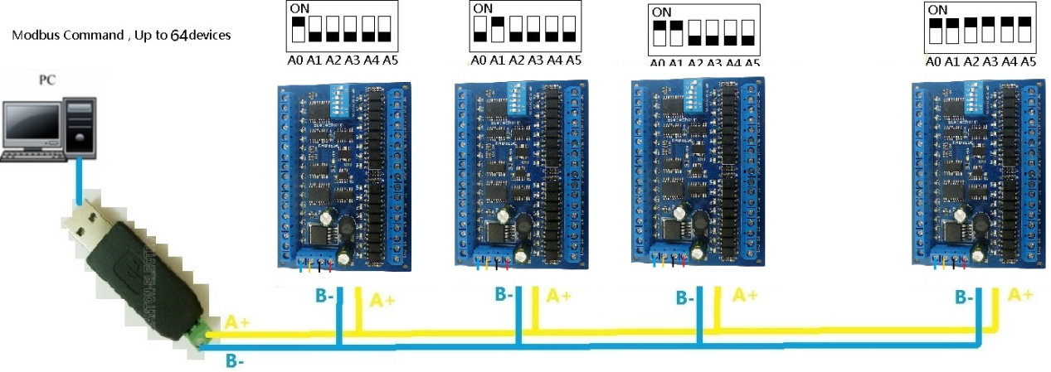

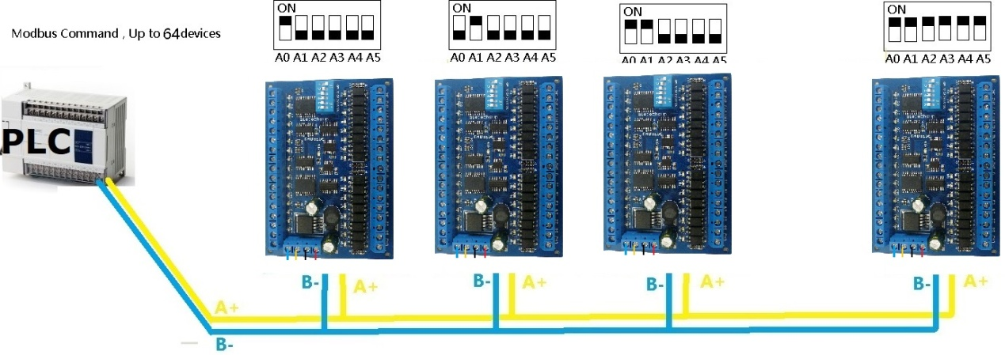

MODBUS command mode (HEX), you can control a variety of ways: Serial Hyper Terminal Control (need to manually add the CRC), Modbus Poll software control (software automatically add the CRC), PLC or MCU process control

